**Chapter 5 : TESTING**

#### 5.1 Test Plan

**INTRODUCTION**

The Test Plan is designed to prescribe the scope, approach, resources, and schedule of all testing activities of the project Talent School App.

The plan identify the items to be tested, the features to be tested, the types of testing to be performed, the personnel responsible for testing, the resources and schedule required to complete testing, and the risks associated with the plan.

**1**. **TEST STRATEGY**

**1.1** **Scope of Testing**

**1.1.1** **Feature not to be tested**

These feature are not be tested because they are not included in the software requirement specs

* User Interfaces
* Hardware Interfaces
* Software Interfaces
* Database logical
* Communications Interfaces

**1.2** **Test Type**

In the project Talent School , there’re 3 types of testing should be conducted.

* **Integration** Testing (Individual software modules are combined and tested as a group)
* **System** Testing: Conducted on acomplete,integratedsystem to evaluate thesystem compliance with its specified requirements
* **API testing:** Test all the APIs create for the software under tested

|  |  |  |
| --- | --- | --- |
| **1.3 Test Logistics** |  |  |
| **1.3.1 Who will test?** |  |  |

The project should use **outsource** members as the tester to save the project cost

**1.3.2When will test occur?**

The tester will start the test execution when all the following inputs are ready

* Software is available for testing
* Test Specification is created
* Test Environment is built

**2.** **TEST OBJECTIVE**

The test objectives are to **verify** the Functionality of Application Talent School , the project should focus on testing the **operation** such as Login, viewing activities, and details of school. to **guarantee** all these operation can work **normally** in real environment.

**3** **TEST CRITERIA**

**3.1** **Suspension Criteria**

If the team members report that there are **40%** of test cases **failed**, suspend testing the development team fixes all the failed cases.

**3.2** **Exit Criteria**

Specifies the criteria that denote a **successful** completion of a test phase

**Run** rate is mandatory to be **100%** unless a clear reason is given.

**Pass** rate is **80%,** achieving the pass rate is **mandatory**.

**4**. **RESOURCE PLANNING**

|  |  |  |  |  |  |  |  |  |  |  |  |  |  |  |  |
| --- | --- | --- | --- | --- | --- | --- | --- | --- | --- | --- | --- | --- | --- | --- | --- |
|  |  |  |  | | | | |  |  |  |  |  |  |  |  |
|  |  |  |  |  | |  |  |  |  |  |  |  |  |  |  |
| **No.** |  |  |  | **Member** | |  |  |  |  |  |  | **Tasks** |  |  |  |
|  |  |  |  |  |  |  |  |  |  |  |  |  |  |  |  |
| **1.** |  |  | Test Manager | | |  |  |  |  | Manage the whole project | | |  |  |  |
|  |  |  |  |  |  |  |  |  |  |
|  |  |  |  |  |  |  |  |  |  |  | | |  |  |  |
|  |  |  |  |  |  |  |  |  |  | Define project directions | | |  |  |  |
|  |  |  |  |  |  |  |  |  |  | Acquire appropriate resources | | |  |  |  |
|  |  |  |  |  |  |  |  |  |  |  |  |  |  |  |  |
| **2.** |  |  | Test | | |  |  |  |  | Identifying | and | describing | appropriate | test | |
|  |  |  |  |  |  |  |
|  |  |  |  |  |  |  |  |  |  | techniques/tools/automation architecture | | |  |  |  |
|  |  |  |  |  |  |  |  |  |  | Verify and assess the Test Approach | | |  |  |  |
|  |  |  |  |  |  |  |  |  |  | Execute the tests, Log results, Report the defects. | | | |  |  |
|  |  |  |  |  |  |  |  |  |  | Outsourced members | | |  |  |  |
|  |  |  |  |  |  |  |  |  |  |  |  |  |  |  |  |
| **3.** |  |  | Developer in Test | | | | |  |  | Implement the test cases, test program, test suite etc. | | | |  |  |
|  |  |  |  |  |  |  |
|  |  |  |  |  |  |  |  |  |  |  |  |  |  |  |  |
| **4.** |  |  | Test Administrator | | | | |  |  | Builds up and ensures test environment and assets are managed | | | | | |
|  |  |  |  |  |
|  |  |  |  |  |  |  |  |  |  | and maintained | |  |  |  |  |
|  |  |  |  |  |  |  |  |  |  | Support Tester to use the test environment for test execution | | | | | |
|  |  |  |  |  |  |  |  |  |  |  |  |  |  |  |  |
| **5.** |  |  | SQA members | | |  |  |  |  | Take in charge of quality assurance | | |  |  |  |
|  |  |  |  |  |  |  |  |  |  |
|  |  |  |  |  |  |  |  |  |  | Check to | confirm | whether the testing process is | | meeting |  |
|  |  |  |  |  |  |  |  |  |  |  |
|  |  |  |  |  |  |  |  |  |  | specified requirements | | |  |  |  |
|  |  |  | | | | | | |  |  |  |  |  |  |  |

Table 5.1: Planning of resources.

**6**. **SCHEDULE & ESTIMATION**

**6.1** **All project task and estimation**

|  |  |  |  |  |  |  |  |  |
| --- | --- | --- | --- | --- | --- | --- | --- | --- |
|  | **Task** |  |  | **Members** |  |  | **Estimate effort** |  |
|  |  |  |  |  |  |
|  |  |  |  |  |  |  |  |  |
|  | **Create the test** |  |  | Test Designer |  |  | 170 man-hour |  |
|  | **Specification** |  |  |  |  |  |  |  |
|  |  |  |  |  |  |  |  |
|  |  |  |  |  |  |  |  |  |
|  | **Perform Test** |  |  | Tester, Test Administrator |  |  | 80 man-hour |  |
|  | **Execution** |  |  |  |  |  |  |  |
|  |  |  |  |  |  |  |  |  |
|  | **Test Report** |  |  | Tester |  |  | 10 man-hour |  |
|  |  |  |  |  |  |  |  |  |
|  | **Test Delivery** |  |  |  |  |  | 20 man-hour |  |
|  |  |  |  |  |  |  |  |  |
|  | **Total** |  |  |  |  |  | **280 man-hour** |  |
|  |  |  |  |  |  |  |  |  |

Table 5.2: Project Tasks

**6.2** **Schedule to complete these tasks**

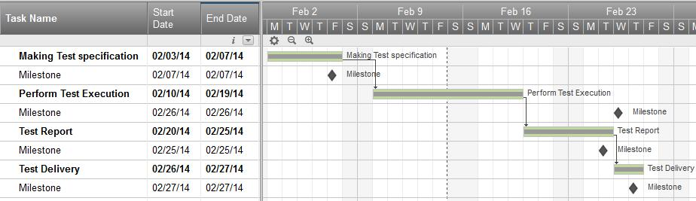

Table 5.3: Project Tasks

**7**. **TEST DELIVERABLES**

Test deliverables are provided as below

**7.1** **Before testing phase**

* Test plans document.
* Test cases documents
* Test Design specifications.

**7.2** **During the testing**

* Test Tool
* Simulators.
* Test Data
* Test Trace-ability Matrix
* Error logs and execution logs.

**7.3** **After the testing cycles is over**

* **Test Results/reports**
* Defect Report
* Installation/ Test procedures guidelines
* **Release notes**